CROP RECOMMENDATION SYSTEM

by
ABHYUDAY SINGH MANDLOI (18BLC1159)

A project report submitted to
Dr. MENKA PUSHPA
SCHOOL OF ELECTRONICS AND COMPUTER ENGINEERING
in partial fulfilment of the requirements for the course of
CSE3019 – DATA MINING
in
B.Tech. ELECTRONICS AND COMPUTER ENGINEERING


Vandalur – Kelambakkam Road
Chennai – 600127

JUNE 2021

BONAFIDE CERTIFICATE

Certified that this project report entitled “IoT BASED MAKING AGRICULTURE PROFITABLE” is a bonafide work of ABHYUDAY SINGH MANDLOI -18BLC1159 who carried out the Project work under my supervision and guidance for DATA MINING.

Dr. Menka Pushpa
Associate Professor
School of Electronics Engineering (SENSE),
VIT University, Chennai
Chennai – 600 127.

ABSTRACT

In this project, we intend to create a wireless sensor network to monitor the various conditions inside a rice field, such as soil moisture, temperature, pH and light intensity. India being an agriculture country, its economy predominantly depends on agriculture yield growth and agroindustry products. Data Mining is an emerging research field in crop yield analysis. Yield prediction is a very important issue in agricultural. Any farmer is interested in knowing how much yield he is about to expect. Analyze the various related attributes like location, pH value from which alkalinity of the soil is determined. Along with it, percentage of nutrients like Nitrogen (N), Phosphorous (P), and Potassium (K)
Location is used along with the use of third-party applications like APIs for weather and temperature, type of soil, nutrient value of the soil in that region, amount of rainfall in the region, soil composition can be determined. All these attributes of data will be analyzed, train the data with various suitable machine learning algorithms for creating a model

ACKNOWLEDGEMENT

I would like to express my special thanks of gratitude to my teacher REKHA D as well as our college VIT Chennai who gave me the golden opportunity to do this wonderful project on the topic “Making Agriculture Profitable” which also helped me in doing a lot of Research and i came to know about so many new things I am really thankful to them.
Secondly i would also like to thank my parents and friends who helped me a lot in finalizing this project within the limited time frame.

TABLE OF CONTENTS

SL. NO. |  | TITLE | PAGE NO.
 |  | ABSTRACT | 3
 |  | ACKNOWLEDGEMENT | 4
1 |  | INTRODUCTION | 6
 | 1.1 | OBJECTIVES | 6
 | 1.2  1.3 | LITERATURE SURVEY  NEED FOR PRECISION AGRICULTURE | 6
 | 1.4 | ORGANIZATION OF THE REPORT | 8
2 |  | IoT BASED PRECISION AGRICULTURE FOR RICE CROP SYSTEM - DESIGN | 7-16
 | 2.1  2.2  2.3  2.4 | DESIGN APPROACHES  BLOCK DIAGRAM OF SYSTEM DESIGN  STANDARDS  CONSTRAINTS, TRADE-OFFS AND ALTERNATIVES | 7  8  13  14
 | 2.5  2.6 | HARDWARE SPECIFICATIONS  SOFTWARE SPECIFICATIONS | 15  16
3 | 3.1  3.2 | IoT BASED PRECISION AGRICULTURE FOR RICE CROP SYSTEM - IMPLEMENTATION AND ANALYSIS  SYSTEM IMPLEMENTATION  RESULTS AND INFERENCES  WEBPAGE RESULT | 17-22  17  21  24
4 |  | COST ANALYSIS | 23
5 |  | CONCLUSION AND FUTURE WORK | 26
 | 5.1 | CONCLUSION | 26
 | 5.2 | FUTURE WORK | 28
APPENDIX
6 REFERENCES 29
BIO-DATA 30
CHAPTER 1
INTRODUCTION

The idea of precision agriculture has been around since the advent of various wireless communication technologies like GPS, GNSS, Wi-Fi etc. In today’s world, farmers can use these technologies along with sensors in order to control various parameters within their fields. WSN (Wireless Sensor Network) is best suited for this purpose, as it assists in computing, communication and control within devices. By implementing a smart decision-making algorithm, various parameters various parameters inside a farm like moisture, temperature, pH and light intensity can be controlled. This will help the farmers increase and monitor the yield of their crops.

  - OBJECTIVES
The following are the objectives of this project:
- To create a wireless sensor network to monitor the various conditions inside a rice field. (Soil moisture, temperature, pH and light intensity).
- To collect sensor values.
- To classify these values (decision mechanism) at the server and send appropriate response to the nodes.
- To show the various parameters of the field in real time.
- ACCORDING TO DIFFERENT ATTRIBUTES SYSTEM SHOULD RECOMMEND WHICH CROP IS SUITABLE TO GROW IN THE REGION.

  - LITERATURE SURVEY
A similar project was undertaken by students of World Academy of Science, Engineering and Technology to monitor plants inside a greenhouse. They used Star network topology to monitor the micro climate close to plants and control irrigation process. Sensing nodes were deployed inside the greenhouse among plants to measure climate parameters (Temperature and Humidity).

They found that the system had the ability for real-time monitoring the temperature and humidity surround plants and controlling soil water contain to obtain maximum crop growth in the greenhouse. The system depended on high accuracy and short time response sensors to collect climate data to extend life time of the system.Their work can be found at the following link [5]. But unlike this, in our project, intends to measure parameters other than temperature and moisture, i.e. pH and light intensity. The amount of lime required will also be calculated based on the pH value.
- For predicting the yield the algorithm takes parameters such as Maximum temperature, average temperature, minimum temperature, area, production, crop, etc.
- The collected data is then validated and processed using analysis tool
- Helping farmers by the idea of providing Wireless sensor network for the crop yield estimation, so that right crop can be chosen.
- It consists of sensors like temperature, rainfall, and moisture sensor to monitor the plants. These sensors will sense the data
- The collected data is then uploaded in the cloud
- The parameters include soil temperature, atmospheric temperature, and humidity, pH. The advisor will suggest the crop and the predicted crop productivity.
- The advantage of this system is it is easily accessible by the farmers. This system would be better if the advisor parameters can be driven from real-time.

Table 1.1 shows the parameters and conditions that govern the optimum yield of rice fields. Also describes the pH values and corresponding fertilizers required in order to maintain the optimum conditions.
Table 1.1 Literature Survey
Sl.  No. | Name of article | Name of journal | Information included
1. | Fertility and organic matter in submerged rice soils | CURRENT SCIENCE, VOL. 88, NO. 5, 10 MARCH 2005 | Soil temperature and pH
2. | Efficient Fertilizer Use — Soil pH Management | Efficient Fertilizer Use Manual(www.plantstress.com/articles/toxicity_m/soilph%20amend.pdf) | Liming conditions
3. | The role of nitrogen fertilizer in soil pH levels | AG Professional | Fertilizer and pH relationship
4. | Greenhouse micro climate monitoring based on WSN with smart irrigation technique | International Journal of Electrical, Computer, Energetic, Electronic and Communication Engineering Vol:7, No:12, 2013 | - Sampling rate t0(20 mins)  - Idea for developing wireless sensor based smart agriculture
5. | Cultivation of Rice: Suitable Conditions Required for the Cultivation of Rice (6 Conditions) | Your article library (http://www.yourarticlelibrary.com/cultivation/cultivation-of-rice-suitable-conditions-required-for-the-cultivation-of-rice-6-conditions/25491/) | Optimum soil moisture level
6. | Crop Prediction using Machine Learning Approaches | IJERT  Authors : Mahendra N , Dhanush VishwakarmaPaper ID : IJERTV9IS080029 | ML approach to buid suitable model.
7. | Crop Recommendation System through Soil Analysis Using Classification in Machine Learning | International Journal of Advanced Science and Technology, 29(3),

1.3 NEED FOR PRECISION AGRICULTURE
India being an agricultural country needs some innovation in the field of agriculture. This can be achieved through modern technologies which assist computing, communication and control within devices. WSN is well suited for this purpose. Using a smart decision making algorithm, we can control the various parameters inside a farm like moisture, temperature, pH and light intensity. This will help farmers to ensure the yield of their crop.

1.4 ORGANIZATION OF THE REPORT

The remaining chapters of the project report are described as follows:
- Chapter 2 contains the methodology, design approach, standards used and constraints of the methodology used in the project.
- Chapter 3 contains the implementation of precision agriculture with server node algorithm and end node algorithm. It also explains the communication between end node and server node. Project results and inferences are described.
- Chapter 4 gives the cost involved in the implementation of the project and analyses its economic feasibility.
- Chapter 5 concludes the report with discussions about the results obtained and their future implications.
CHAPTER 2
IoT BASED AGRICULTURE FOR HIGH YIELD SYSTEM - DESIGN

This Chapter describes the methodology, design, standards, calibrations, sampling rate and constraints of Precision Agriculture system.

2.1 DESIGN APPROACH

Smart agriculture recommender system is an IoT system, will be used by the farmers to gain advance information in agriculture domain. The system provides information about crops and various government schemes to farmers based on various parameters such as income, acquired land, number of family members, etc. It will be helpful for the farmers to gain crop yield by using appropriate fertilizers suggested by the system. The system can be used by the farmers using smart phones. It is possible to aware farmer about resources that helps to recover losses and provide information about the benefits of “Modern Agriculture Technology’’.

In this system, a Arduino microcontroller board is connected with a ESP8266 Wi-Fi module to connect the wireless system to the Android Application. We have connected a pH sensor, moisture sensor and temperature sensor to detect changes in moisture and temperature. We have created a database to collect data obtained from the application. Data collected will analyzed using data mining techniques.
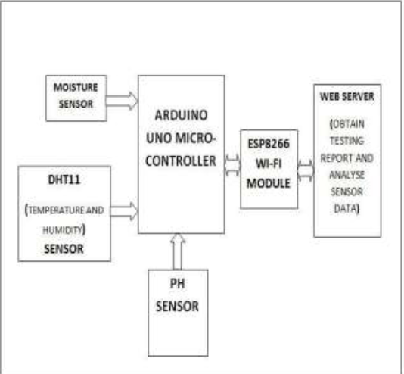
FIG 2.0
2.2 BLOCK DIAGRAM OF SYSTEM DESIGN
The idea implemented in this project is server side decision making, which gives user flexibility while deploying the node, as the thresholds are decided and implemented at the server itself, so if the values change the end-nodes don’t have to be re-programmed, plus the node can have low processing capability.

For demonstration of our project we attached the various sensors for measuring soil moisture, pH, temperature and light intensity, with Arduino uno through the analog input pins as shown in Figure 3.

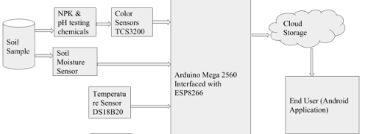

Figure 3. Block diagram

System which contains components namely Sensors, , ThingSpeak Cloud, ML Model, and Crop Assessment and Suggestions. The soil attributes like colour, pH, moisture content, and nutrients are collected using sensors and uploaded into ThingSpeak Cloud. a built in Wi-Fi module which is used to send these values to ThingSpeak cloud that is responsible for storing and generating responses to the android application. These responses sent to the machine learning module which triggers appropriate crop recommendations.
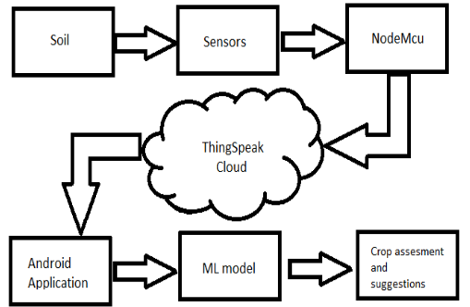

FIG 3.1

TRANMITTER AND RECEIVER

ESP8266 is an inexpensive Wi-Fi microchip.ESP8266 has integrated TCP/IP protocol stack. It can be comfortably attached to microcontroller forgetting access to each Wi-Fi network. ESP8266 can be used with Arduino. It has the ability to hosting an application. Every ESP8266 Wi-Fi module are in-built set up with an AT command. The range of ESP8266 Wi-Fi module is 479 meters along with rubber duck antenna.

ThingSpeak is an IoT analytics platform service that allows you to aggregate, visualize, and analyze live data streams in the cloud. You can send data to ThingSpeak from your devices, create instant visualization of live data, and send alerts. Collect, Send sensor data privately to the cloud. Analyze and visualize your data with MATLAB.

2.3 STANDARDS
This section describes the standards used for the WSN and the border router.

2.3.1 For WSN (local wireless Sensor network)

Physical, Mac and Datalink layer: 802.11 standard
Processor: L106 32-bit RISC microprocessor core based on the Tensilica Xtensa Diamond Standard 106Micro running at 80 MHz[5]
Memory:[citation needed]
32 KiB instruction RAM
32 KiB instruction cache RAM
80 KiB user-data RAM
16 KiB ETS system-data RAM
External QSPI flash: up to 16 MiB is supported (512 KiB to 4 MiB typically included)
IEEE 802.11 b/g/n Wi-Fi
Integrated TR switch, balun, LNA, power amplifier and matching network
WEP or WPA/WPA2 authentication, or open networks
17 GPIO pins[6]
SPI
I²C (software implementation)[7]
I²S interfaces with DMA (sharing pins with GPIO)
UART on dedicated pins, plus a transmit-only UART can be enabled on GPIO2
10-bit ADC (successive approximation ADC)

2.5 HARDWARE SPECIFICATIONS

- Moisture sensor: Soil Moisture Sensors measure soil moisture with patented TDT (Time Domain Transmission) technology. biSensors are self-calibrating for all soil types and conditions and are unaffected by salty soil conditions or soils with a high pH. biSensors can be connected to a two-wire path or conventional wire and provide continuous measurements and real-time feedback for the controller to make smart irrigation decisions specific to the landscape the biSensor is installed in.
- Temperature sensor LM35: The LM35 series are precision integrated-circuit Calibrated Directly in Celsius (Centigrade) temperature devices Factor proportional to the Centigrade temperature.
- Hydrofarm MGMLP1 Active Air 3-Way pH, Light and Moisture Meter: pH readings between pH 4 and 8.
- LDR: Two cadmium sulphide (cdS) photoconductive cells with spectral responses similar to that of the human eye. The cell resistance falls with increasing light intensity.
- ARDUINO: will be used as border router.
- Wifi router: to provide internet access.
- Jumper wires: for connections.
- WIFI module.

2.6 SOFTWARE SPECIFICATIONS

  - ATMEGA C Programming.
  - Python Programming.
  - KNIME ANALYTICS.
  - TINKERCAD SIMULATION.

CHAPTER 3
IoT & ML BASED AGRICULTURE FOR PROFITABLE YIELD SYSTEM - IMPLEMENTATION AND ANALYSIS

This section describes system implementation and results with inferences.

3.1 SYSTEM IMPLEMENTATION

3.1.1 HARDWARE SIMULATION

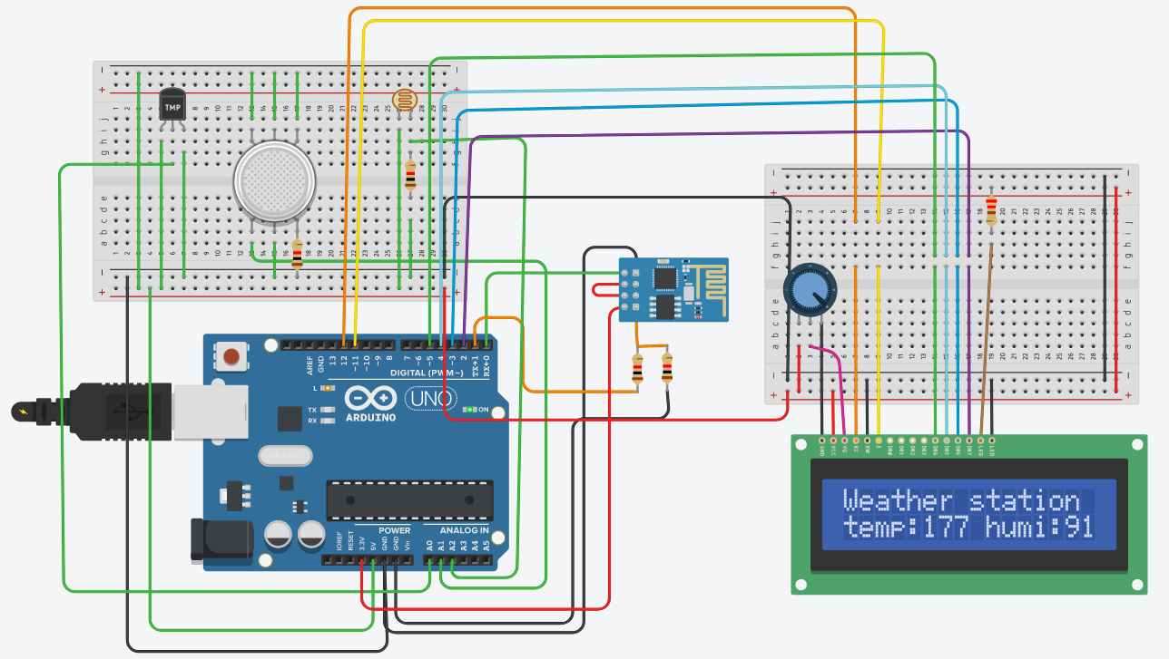

FIG. HARDWARE IMPLEMENTATION

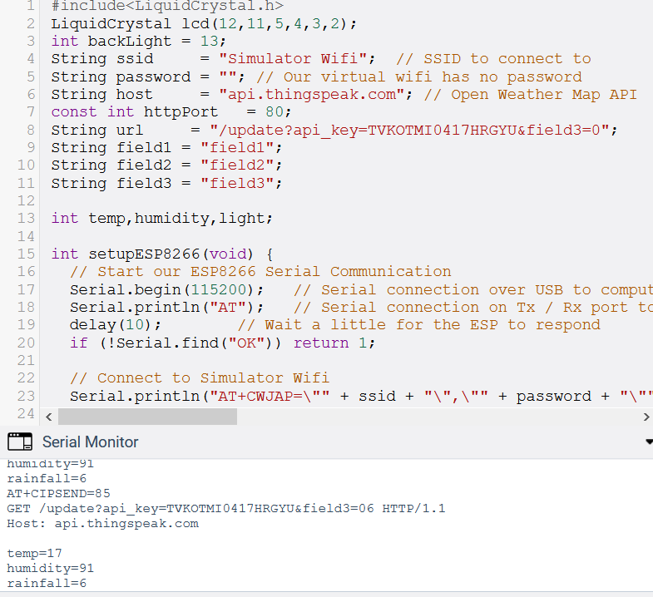

FIG. CODE AND SENSOR VALUES

From hardware part from sensor we will get values and will be sent to ThingSpeak cloud using Wi-Fi module.

3.1.2 ThingSpeak Cloud

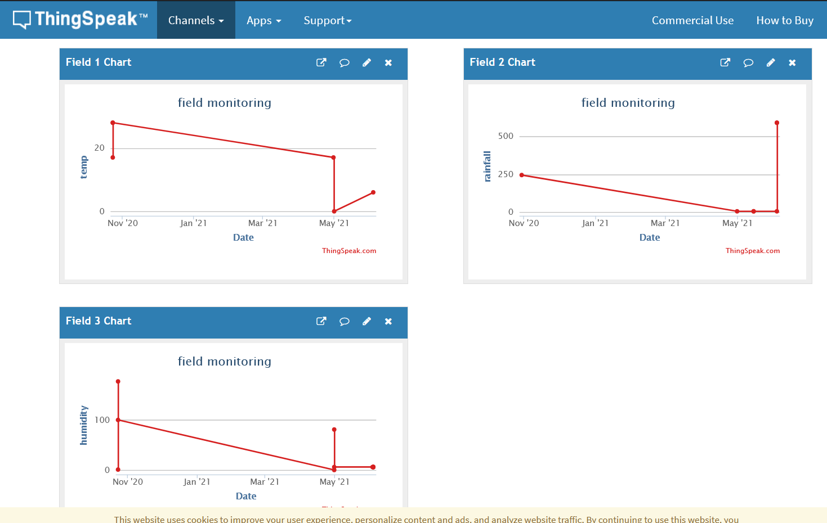

FIG. THINGSPEAK DASHBOARD

3.1.2 DATA MINING IMPLEMENTATION

DATASET

The dataset used for the crop suggestion model is collected from the open source websites which contain various parameters related to the cultivation of crops. The dataset is prepared in a way in which it consists of about thirteen attributes like soil type, land type, soil moisture, temperature, humidity, pH, the area sown, soil N, soil P, soil K, rainfall, production, class label.

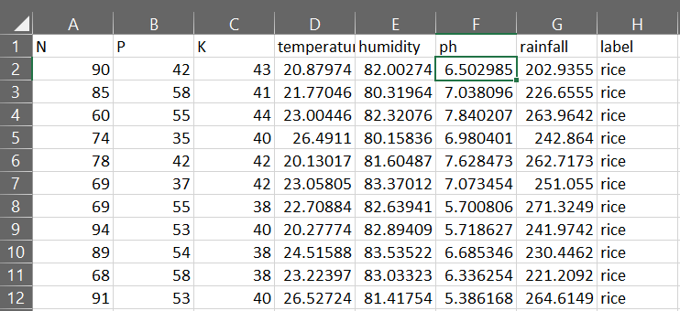

FEATURE DESCRIPTION

The soil moisture sensor, temperature and humidity sensor readings can be measured and used for processing. The features soil Nitrogen (N), Phosphorous (P), and Potassium (P) simply called NPK is helpful for boosting up plant growth by improving the soil fertility.

Data Preprocessing

Label Encoding refers to converting the labels into numeric form so as to convert it into the machine-readable form. Machine learning algorithms can then decide in a better way on how those labels must be operated. It is an important pre-processing step for the structured dataset in supervised learning.

ATTRIBUTE LIKE CROP , CONVERTED TO NUMERICAL VALUE

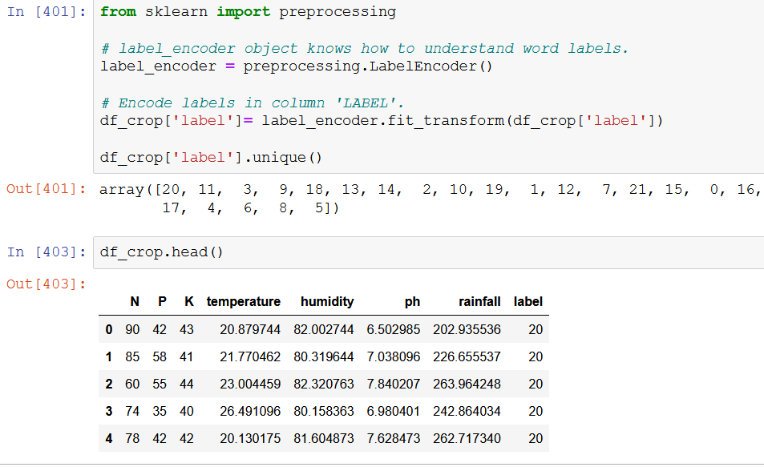

Data Preprocessing

Scaling Features:
Taking a look at the dataset above, it contains features highly varying in magnitudes, units and range. The features with high magnitudes will weigh in a lot more in the distance calculations than features with low magnitudes.
To suppress this effect, we need to bring all features to the same level of magnitudes. This can be achieved by scaling.

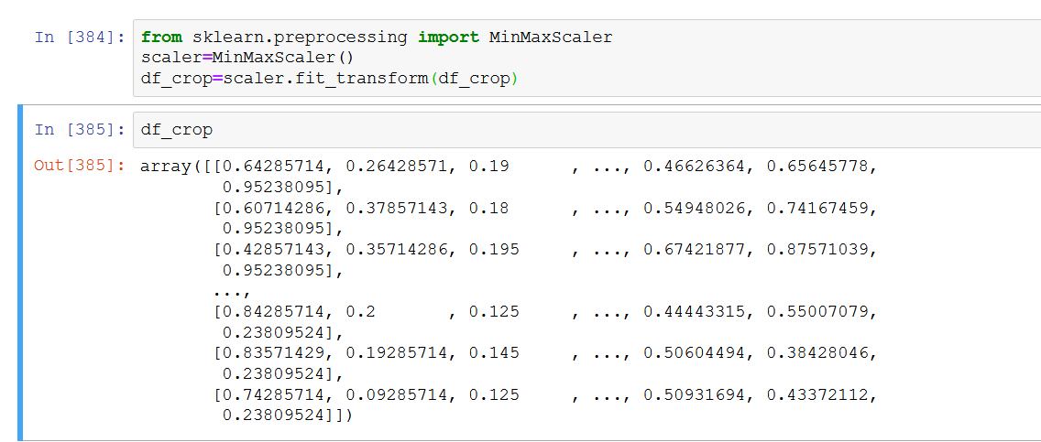

MACHINE LEARNING ALGORITHMS:

Decision Tree Algorithm

A decision tree is a data structure that is built using nodes (containing values or conditions) and edges (connecting all nodes). The decision tree is constructed based on a dataset containing attributes or features which classify the raw data for each record. Each node in the tree can be either a decision node that makes decisions or a leaf node that gives the outcome. The algorithm uses Decision Tree to classify and recommend the crops the farmers should grow.

Random Forest Algorithm

The random forest algorithm is a supervised learning algorithm which can apply for both classification and regression type datasets. It will randomly select a certain set of features from the given dataset attributes and create a set of decision trees by finding the root nodes and splitting the attributes. After creating the forest then the best decision is chosen based on highest votes acquired among the predicted targets as the final prediction from the classifier. The random forest classifier accuracy increases with increase in number of trees in the forest.

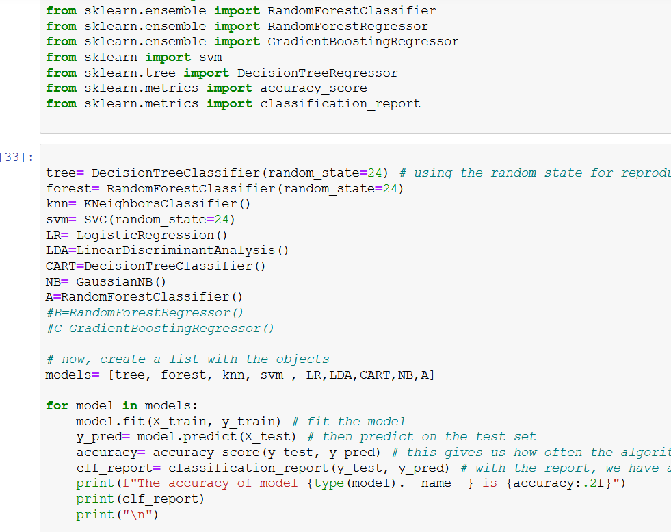

ACCURACY OF ONE OF THE MODEL:
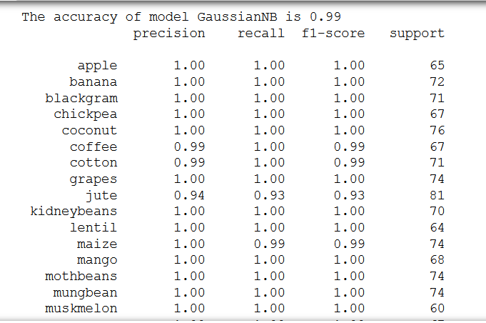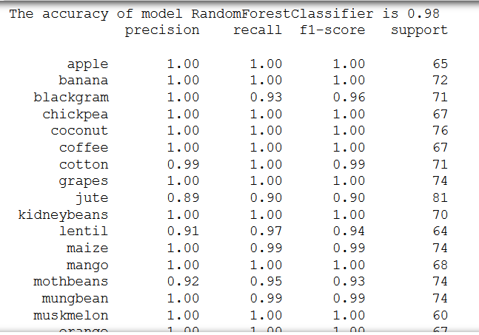

APPLYING GaussianNB model on DATASET WE GET
FOLLOWING OUTPUT , AS ACCURACY OF 99% AS SHOWN BELOW.
PREDICTED COLUMN WE CAN SEE THE PREDICTION IN BELOW SCREENSHOT
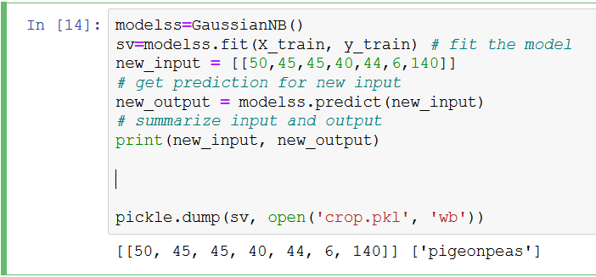

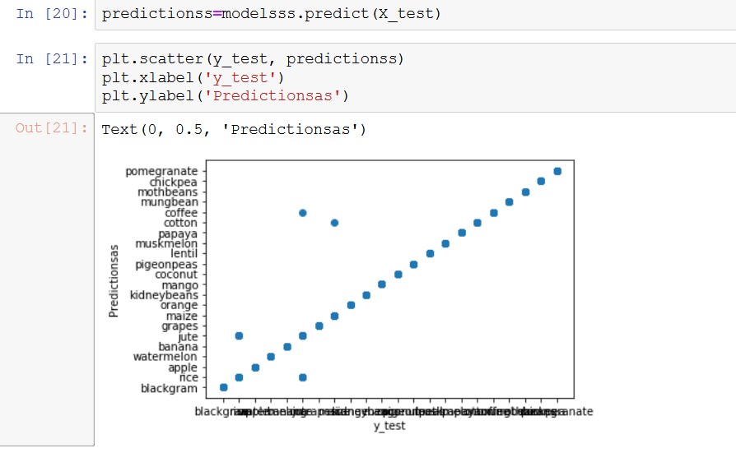

VISUALISATION OF PRIDICTION:
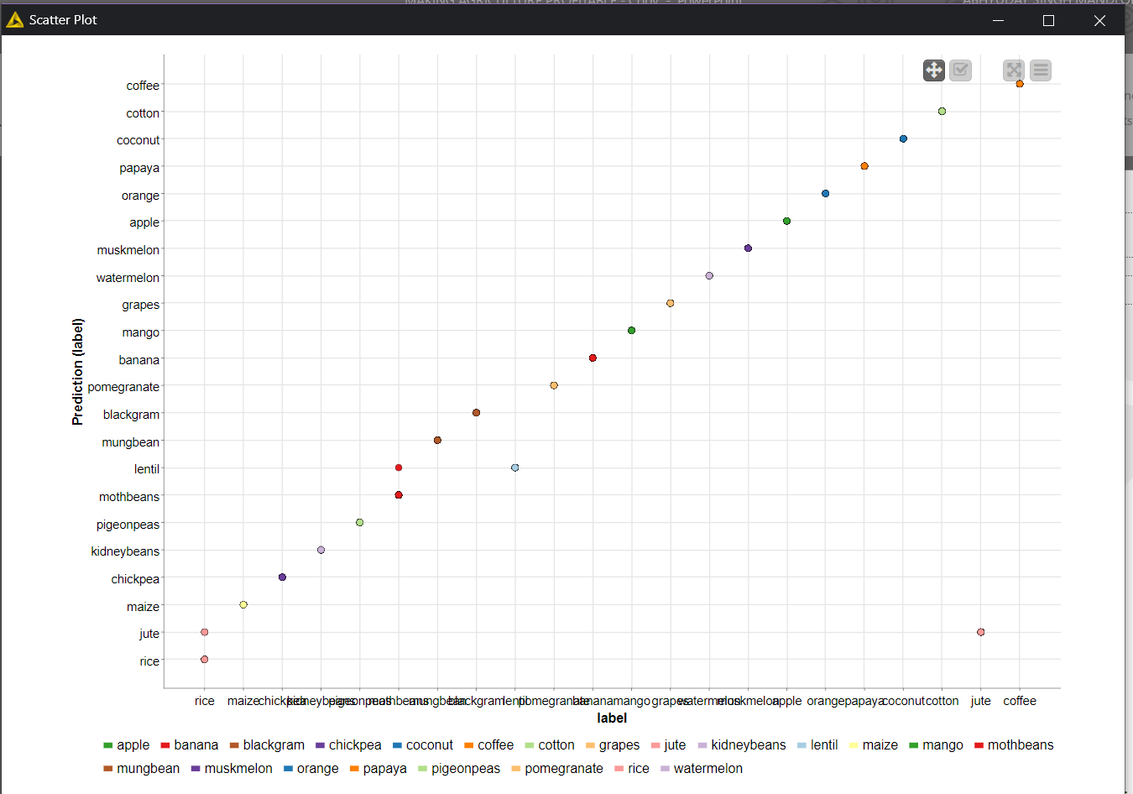

FIG. TEST VS PREDICTED

ABOVE GRAPH IS LINEAR WHICH SHOWS THE ACCURACY OF ALGORITHM

FINAL RESULT OF WEBPAGE

WEBPAGE USING “flask”

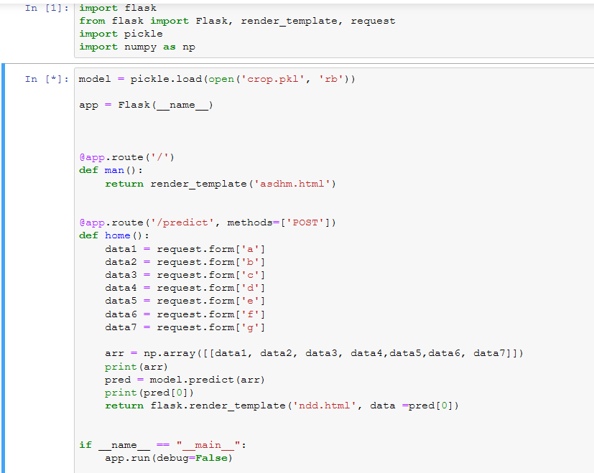

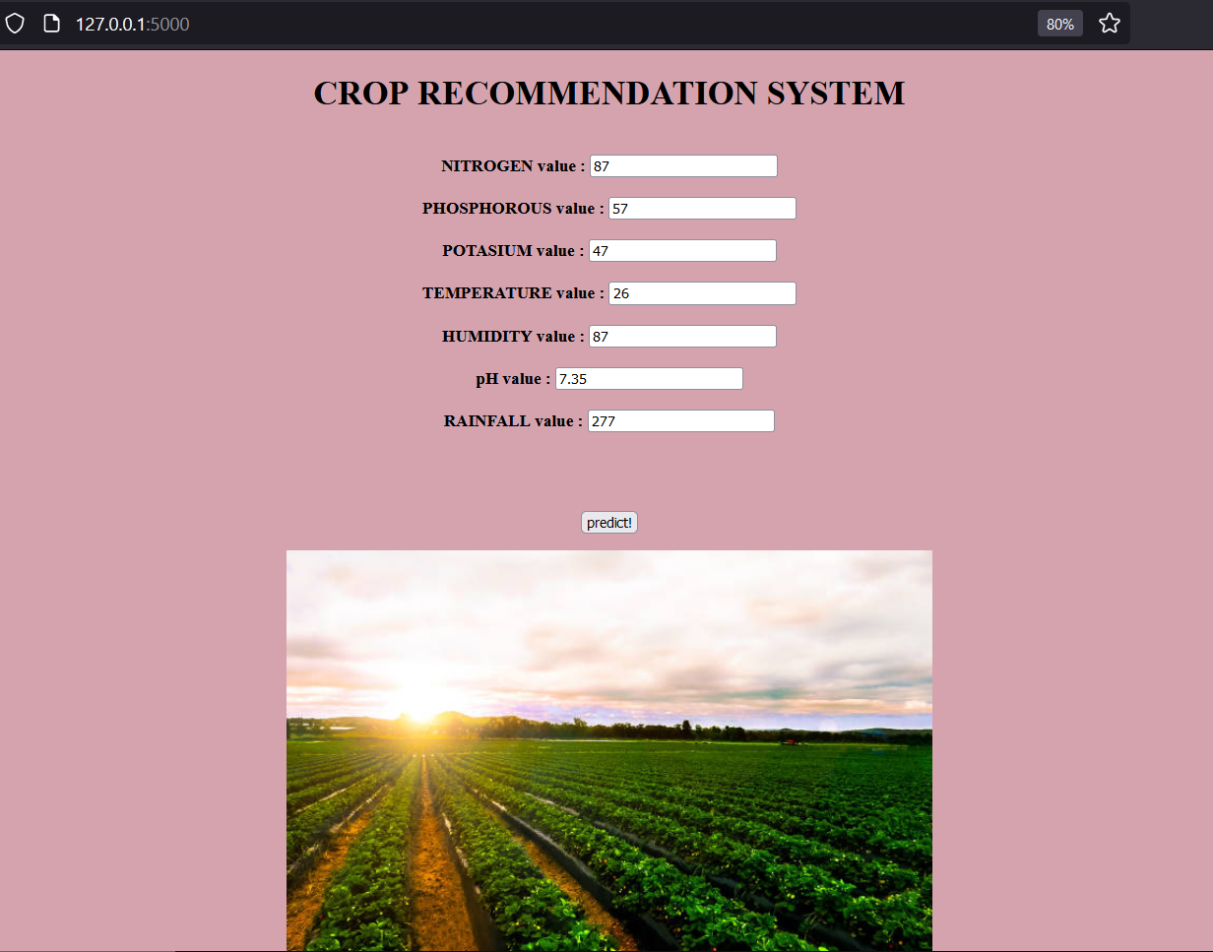

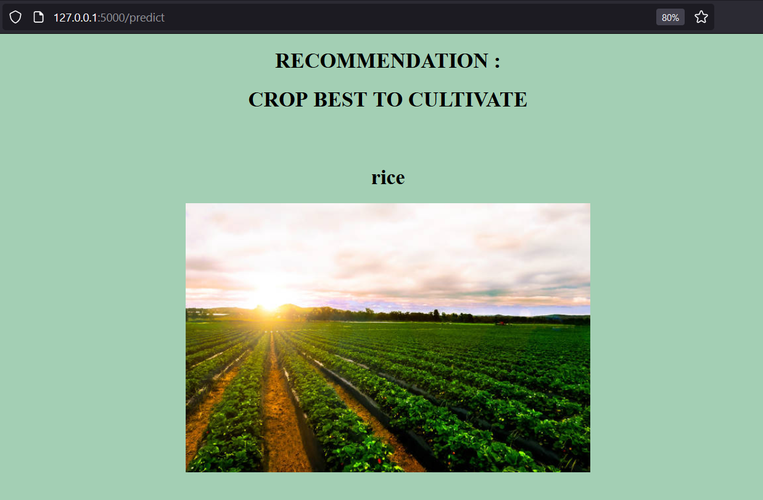

SAME OUTPUT WE GOT ON BACKEND FOR INPUT VALUES

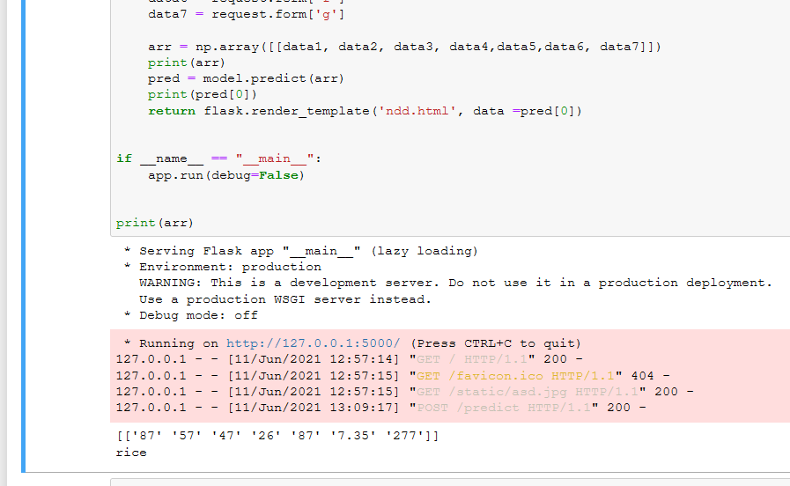

3.2 RESULTS AND INFERENCES

The overall implementation of sensors data acquisition and communicating to coordinator. The coordinator node executes end-node algorithm.

A methodological approach has been followed in designing the IoT Based Recommendation System Using Soil Nutrient And Environmental Condition Detection. The experimental result obtained from the designed system has shown that the system performance is accurate and reliable. Ground level experience has shown that the soil nutrient level identification is very much helpful to restrict the underuse or overuse of fertilizers in the field and thus it has increased the production level of crops.
The crop selection module in the app retrieves the latest pH, moisture, and npk values of soil from the cloud and performs various operations to display the soil type and recommend a suitable crop.

CONCLUSION

Agriculture is a major input sector for economic development of our country. Traditional agricultural system suffers from many problems that are caused due to ill soil health. The proposed system provides a very useful Android based application that facilitates an interface for farmers to monitor soil conditions and generate recommendations to improve crop production. The model includes interfaces for crop selection, maintenance of soil moisture and nutrient contents during plant growth. The modules are implemented using main components such as sensors and the Arduino, and the algorithms that are used in this system. The developed system is user friendly and gives proper suggestions. Automated crop recommendation system has tremendous demand and potential for the future too. It is time-saving, leading to the elimination of human error in adjusting the available levels of soil moisture and optimizing net profits in terms of factors such as market price, product quality and production. It involves the additional sensors and outputs implemented by the system at an enhanced degree of smart interventions.

CODE ANALYSIS

- Number of Lines: 154 (Arduino)+ 100 (ML)

CHAPTER 5
CONCLUSION AND FUTURE WORK

5.1 CONCLUSION

- The Wireless Iot Mesh system was built and implemented.
- The system is targeted at rural agricultural farm lands.
- The prototype developed can control electrical devices in any field
- The system implements the wireless network using RF modules for their efficiency and low power consumption.
- The preliminary test results are promising.

5.2 FUTURE WORK

- Voice operated system can be implemented
- Adding confirmation commands to the voice recognition system.
- Integrating variable control functions to improve the system versatility such as providing control commands other than ON/OFF commands. For example “Increase Temperature”, “Turn on water pump” etc.
- Integration of GSM or mobile server to operate from a distance.
- Design and integration of an online web control panel.

CHAPTER 6
REFERENCES

1.) Muthunoori Naresh, P Munaswamy, “Smart Agriculture System using IoT Technology”, International Journal of Recent Technology and Engineering (IJRTE)
2.) AnandNayyar, Er. Vikram Puri , “Smart Farming: IoT Based Smart Sensors Agriculture Stick for Live Temperature and Moisture Monitoring using Arduino, Cloud Computing & Solar Technology, using Internet of Things”.
3.) S.Pudumalar*,E.Ramanujam*, R.HarineRajashreeń, C.Kavyań, T.Kiruthikań, J.Nishań, “Crop Recommendation System for Precision Agriculture”, IEEE Eighth International Conference on Advanced Computing (ICoAC), 2016
4.) EkataGhadage, VibhavariKharate, Parnika Mane, SamruddhiPimpale, SantwanaGudadhe, “Intelligent support system to recommend suitable Crops: using arduino microcontroller”, International Journal of Advance Computational Engineering and Networking (IJACEN), Vol. 5, 2017

LIST OF PUBLICATIONS

INTERNATIONAL CONFERENCES / JOURNALS

- XXXXX, “IoT BASED PRECISION AGRICULTURE SYSTEM FOR RICE CROP”, ARPN Journal (April 2016 Communicated).

BIODATA

Name: ABHYUDAY SINGH MANDLOI
Mobile Number: 9826990507
E-mail: abhyudaysingh.mandloi2018@vitstudent.ac.in
Permanent Address: INDORE, MP

